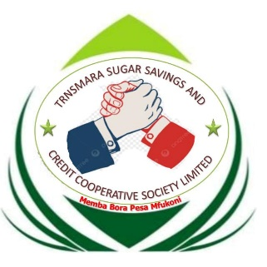

TRANSMARA SUGAR SAVINGS & COOPERATIVE SOCIETY LTD

P. O. BOX 113-40700, KILGORIS
Tel: 0714251019
Email:info@transmarasacco.co.ke

BOOSTIKA APPLICATION FORM
PART I: LOAN APPLICATION FORM

Interest Chargeable
  - Interest for loan applied will be charged at 20%
  - Maximum repayment period is 3 Months.
  - Maximum of 50% of share capital

Applicant’s Details
Name of Applicant: Payroll Number: Membership No: Year of Birth: Amount applied for: In words:
(Amount in figures)

Society Official: Yes No

Salary Details

(If yes, state position held in Society)

- Gross Salary Ksh: (iii) Net Pay Ksh:
- Basic Salary Ksh: (iv) 1/₃ Basic Pay Ksh:
PART II: AUTHORITY TO DEDUCT SALARY
I hereby, authorize my employer to effect monthly deductions from my salary as stated herein below for the loan granted plus interest according to the Society’s Loan Policy.

In the event that I leave the service of the employer before settlement of the loan, I hereby do authorize that the outstanding balance be offset from my terminal benefits and/or my share contributions in the Society.
Phone Number: Name of Applicant/Member: National ID Number/Passport Number:
Signature Date

OFFICIAL USE ONLY:

Total Deposits Held

Amount applied

Loan Balance(s)

Net amount Entitled

Instalments Amount

I certify that the application is within the Rules of the Society and the application is:
Approved Not approved Reasons:
Name: Signature: Date:

- Loans Committee’s Recommendation

The Loans Committee analyzed the application and resolved as below:

Approved Rejected Reasons:

The above resolution is hereby signed by the Committee on:
^{(Date)}
Chairperson: Secretary: Member:
The Treasurer is hereby duly authorised to prepare a cheque for the amount approved herein above subject to availability of funds.
- Administration of Loan
Loan granted on: Vide Cheque No:
Amount Ksh: Repayment deductions to commence from:

